<https://www.bonedo.de/artikel/einzelansicht/native-instruments-traktor-evolution-der-dj-software.html>

# Native Instruments Traktor: Evolution of DJ software

## A look back at two decades of digital DJ culture

by [Mijk van Dijk](https://www.bonedo.de/autor/information/mijk-van-dijk.html)

11/16/2018

[203](https://www.bonedo.de/?type=1249059875&tx_bonedo_ajax%5baction%5d=likeArticle&tx_bonedo_ajax%5barticle%5d=18715)

[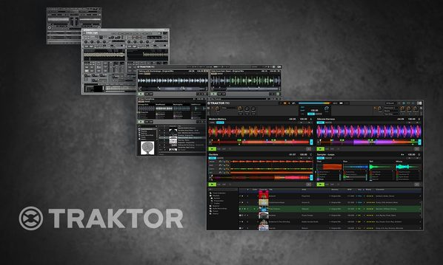](https://www.bonedo.de/fileadmin/_processed_/8/7/csm_The_History_of_native_indtruments_Traktor_20c7511ddd.jpg)

Alongside Serato, Native Instruments Traktor is the most important professional DJ software. Whether mixing only with the laptop, with DVS support or our own highly specialized controllers: Traktor has decisively shaped and promoted the image of the digital DJ and innovations such as loops, beat jump, remix decks, STEM decks and, last but not least, the notorious Sync button introduced to DJ culture.

Within 20 years, the Berlin software company has grown from a small start-up to a global player and has nevertheless been able to maintain its down-to-earthness in Kreuzberg.

On the occasion of the release of Traktor Pro 3 and the also brand new controllers [Kontrol S4 MK3 and Kontrol S2 MK3](https://www.bonedo.de/artikel/einzelansicht/neue-dj-flaggschiffe-bei-ni-traktor-pro-3-software-und-kontrol-s4-mk3-dj-controller-angekuendigt.html) , we met the person at NI who accompanied Traktor from the beginning: Traktor Product Owner Friedemann Becker. A look back at two decades of digital DJing with some very interesting insights behind the scenes.

[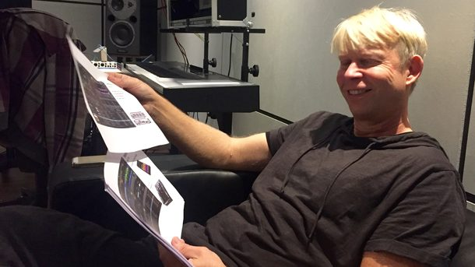](https://www.bonedo.de/fileadmin/_processed_/0/f/csm_02-History_Of_Native_Instruments_Traktor_die_Geschichte_von_Traktor_Scratch_Pro_f1f71626f6.jpg)

*Traktor Product Owner Friedemann Becker reviews 20 years of tractor history (Image: Mijk van Dijk)*

Content:

* [MJ Studio (1998) - "Tractor, I'm Your Father"](https://www.bonedo.de/artikel/einzelansicht/native-instruments-traktor-evolution-der-dj-software.html#MJ%20Studio%20(1998)%20%E2%80%93%20%E2%80%9ETraktor,%20ich%20bin%20dein%20Vater%E2%80%9C)
* [Friedemann Becker and Native Instruments](https://www.bonedo.de/artikel/einzelansicht/native-instruments-traktor-evolution-der-dj-software.html#Friedemann%20Becker%20und%20Native%20Instruments)
* [Traktor DJ Studio (2001) - The first “real” tractor](https://www.bonedo.de/artikel/einzelansicht/native-instruments-traktor-evolution-der-dj-software.html#Traktor%20DJ%20Studio%20(2001)%20%E2%80%93%20Der%20erste%20%E2%80%9Eechte%E2%80%9C%20Traktor)
* [teething problems](https://www.bonedo.de/artikel/einzelansicht/native-instruments-traktor-evolution-der-dj-software.html#Anlaufschwierigkeiten)
* [Tractor: embedded player](https://www.bonedo.de/artikel/einzelansicht/native-instruments-traktor-evolution-der-dj-software.html#Traktor:%20Embedded%20Player)
* [Traktor DJ Studio 2 (October 2002) - Very close to the user](https://www.bonedo.de/artikel/einzelansicht/native-instruments-traktor-evolution-der-dj-software.html#Traktor%20DJ%20Studio%202%20(Oktober%202002)%20%E2%80%93%20Ganz%20nah%20dran%20am%20User)
* [Traktor DJ Studio 2.5 (September 2003) - Beatjump and Key Control](https://www.bonedo.de/artikel/einzelansicht/native-instruments-traktor-evolution-der-dj-software.html#Traktor%20DJ%20Studio%202.5%20(September%202003)%20%E2%80%93%20Beatjump%20und%20Key%20Control)
* [In Sync: Traktor pioneers digital DJing in many areas](https://www.bonedo.de/artikel/einzelansicht/native-instruments-traktor-evolution-der-dj-software.html#In%20Sync:%20Traktor%20in%20vielen%20Bereichen%20Vorreiter%20f%C3%BCr%20digitales%20DJing)
* [Traktor DJ Studio 2.6 (November 2004) The DJ studio with vinyl control](https://www.bonedo.de/artikel/einzelansicht/native-instruments-traktor-evolution-der-dj-software.html#Traktor%20DJ%20Studio%202.6%20(November%202004)%20Das%20DJ-Studio%20mit%20Vinyl-Kontrolle)
* [controllerism](https://www.bonedo.de/artikel/einzelansicht/native-instruments-traktor-evolution-der-dj-software.html#Controllerism)
* [Tractor 3 (September 2005) - Four decks and more](https://www.bonedo.de/artikel/einzelansicht/native-instruments-traktor-evolution-der-dj-software.html#Traktor%203%20(September%202005)%20%E2%80%93%20Vier%20Decks%20und%20mehr)
* [Tractor Scratch (January 2007): Separate ways](https://www.bonedo.de/artikel/einzelansicht/native-instruments-traktor-evolution-der-dj-software.html#Traktor%20Scratch%20(Januar%202007):%20Getrennte%20Wege)
* [Pioneering work - Traktor Pro (October 2008) - A lot at the beginning](https://www.bonedo.de/artikel/einzelansicht/native-instruments-traktor-evolution-der-dj-software.html#Pionierarbeit%20-%20Traktor%20Pro%20(Oktober%202008)%20%E2%80%93%20Vieles%20auf%20Anfang)
* [Traktor Pro 2 (April 2011) - Everything so colorful here](https://www.bonedo.de/artikel/einzelansicht/native-instruments-traktor-evolution-der-dj-software.html#Traktor%20Pro%202%20(April%202011)%20%E2%80%93%20Alles%20so%20sch%C3%B6n%20bunt%20hier)
* [Traktor Pro 2.5 (March 2012) - remixes with the power of four](https://www.bonedo.de/artikel/einzelansicht/native-instruments-traktor-evolution-der-dj-software.html#Traktor%20Pro%202.5%20(M%C3%A4rz%202012)%20%E2%80%93%20Remixen%20mit%20der%20Power%20der%20Vier)
* [Tractor like Accusonus Software Regroover?](https://www.bonedo.de/artikel/einzelansicht/native-instruments-traktor-evolution-der-dj-software.html#Traktor%20wie%20Accusonus%20Software%20Regroover?)
* [The last years of tractor 2](https://www.bonedo.de/artikel/einzelansicht/native-instruments-traktor-evolution-der-dj-software.html#Die%20letzten%20Jahre%20von%20Traktor%202)

### MJ Studio (1998) - "Tractor, I'm Your Father"

In 1994, the Fraunhofer Institute introduced the MP3 standard, a very low-loss compression process to send music files through the still young and rather slow Internet as efficiently as possible. Just four years later and long before the first iPod came onto the market in 2001, the small three-headed company d-lusion interactive media developed the first virtual DJ software for PCs in which MP3s could be mixed with two players and adjusted in speed. [MJ Studio](http://www.d-lusion.com/ProductsMJStudio.html) already offered a three-band equalizer, playlists with ID3 support, a preview function, mouse scratching and even a beat detection. By the way, two of the former founders of d-lusion have now founded the well-known language learning company Babbel. And if you want to dive back into the early days of digital DJing yourself:[The Uropa of all DJ software can still be downloaded for free.](http://www.d-lusion.com/DownloadMJStudio.html" \o "Download MJ Studio" \t "_blank)

[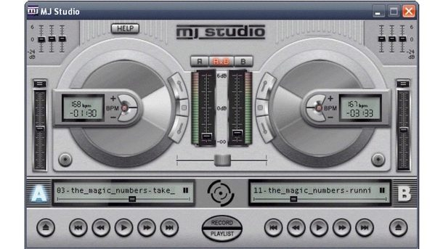](https://www.bonedo.de/fileadmin/_processed_/9/f/csm_03-History_Of_Native_Instruments_Traktor_die_Geschichte_von_Traktor_Scratch_Pro_26988367f0.jpg)

*Traktor 3s great-grandfather: MJ Studio from d-lusion from 1998. This was how digital DJing started 20 years ago. (Image: Courtesy of Native Instruments)*

### Friedemann Becker joined Native Instruments in 2000:

“As a trained physicist, I used Reaktor's precursor generator early on to build all sorts of things that had more to do with measurement technology than music. In the digital modular system, you had all imaginable mathematical functions, you could feed electrical currents and do a lot more with it than just sound. I then approached Native Instruments during the 1999 Frankfurt Music Fair. My first job was reactor community manager, so I built up the reactor user library. ”

The company had just acquired a solid name in the studio scene with innovative software synths such as Reaktor and the first plug-in versions of legendary hardware keyboards such as Pro-52 (Sequential Circuits Prophet-5) and B4 (Hammond B3). Now the Berliners wanted to conquer the DJ area. They looked for developers and came across the company d-lusion and its product MJ Studio. Becker gives an insight into the Stone Age of digital DJing:

“Back then, DJing looked on the computer so that you could mix two instances of Winamp with a crossfader plug-in on a desktop computer. It was not yet pitchable and everything had to be operated using the mouse and key commands. At that time there were no controllers and sound cards specializing in DJs. MJ Studio was also still very basic in terms of functionality, but still capable of pitching so that DJs could adjust the tracks on the computer was a real quantum leap.

We were then able to convince the d-lusion developers to come to us and bring their know-how and IP to us. The Beatgrid was one of the first things we put a lot of energy into to make it reliable and marketable, because that's the prerequisite for satisfactory sync functionality. Like many great instruments at NI, this beat detection was also developed in a reactor and later ported and patented to C ++. This is one of the technical contributions that I have made to Traktor as a physicist over the years. "

[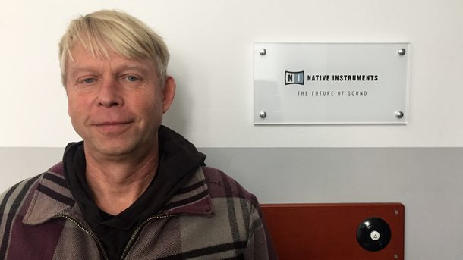](https://www.bonedo.de/fileadmin/_processed_/0/b/csm_04-History_Of_Native_Instruments_Traktor_die_Geschichte_von_Traktor_Scratch_Pro_a54481063e.jpg)

*Traktor Product Owner Friedemann Becker in a large Bonedo interview (Image: Mijk van Dijk)*

### Traktor DJ Studio (2001) - The first “real” tractor

In 2001, Traktor DJ Studio was created as a further development of MJ Studio with Friedemann Becker as project manager.

“The first thing we did was redesign the surface. The interaction with the music should become more visible, tangible and therefore more immediate than simply pressing start and stop. This was then the representation of the waveform, in which you could quickly select and scratch a certain position with the mouse, similar to a record. There was also a comfortable browser and a completely new design, because Native Instruments has always defined and stood out about the design. An NI-typical filter was also important to us, also inspired by the then very popular [Allen & Heath Xone: 92 console](https://www.bonedo.de/artikel/einzelansicht/allen-heath-xone92-test.html) and its filter mixing capabilities long before Pioneer and the other companies introduced filters in their mixers. Nevertheless, the design was still very playful, lots of round elements, later we became much more sober. But there was already a master clock and the phase meter, which shows the synchronicity of the two decks.

It was also important to us to make the software controllable by a controller. That's why we made it MIDI-compatible to be able to connect Traktor to general-purpose MIDI controllers such as Doepfer Pocket Control and Behringer BCF-2000. This was one of the very important first steps for Traktor to be taken seriously by professional DJs who go on stage and really want to screw there. However, some of our first “evangelists” were also “mouse DJs”, like they played a lot in the WMF Club in Berlin. Another user from the very beginning was the Frankfurt drum 'n' bass producer Kabuki, who already played the first version of Traktor at the 2001 Fusion Festival.

Of course, we spared no effort or expense in getting our Bonedo author colleague Manuela Krause to make a statement

“I hung up on the computer right from the start and even dragged my iMac G3 into the WMF. I had installed one of the first MP3 software on it:  [Tactile 12000](https://tactile12000.informer.com/2.1/) . Put on and mix with the mouse! That was really messy. It was only possible with a fast crossfade or track by track. Then a buddy lent me his laptop with tractor for a tour to Tel Aviv and I was absolutely thrilled! Then I voluntarily bought a PC laptop and put my fat Mac in the corner!

The colleagues' reactions were funny: I wasn't "just a woman" behind the deck, I also hung up on the computer. The other DJs didn't take that seriously at first. They thought it was totally funny, but not professional. The only one I got positive feedback from was [Electric Indigo (here in Gear Chat)](https://www.bonedo.de/artikel/einzelansicht/gear-chat-electric-indigo.html) , she heard and saw me at a rave in Sarajevo!

I thought the DJing with the first two tractor versions was fantastic! Beat mixing with the mousepad and keys was very rhythmic and easy. The nice thing: Back then, Traktor was still very minimalistic, reduced to the essentials, and yet you could rock the floor properly if you played the right music at the right time. ”

[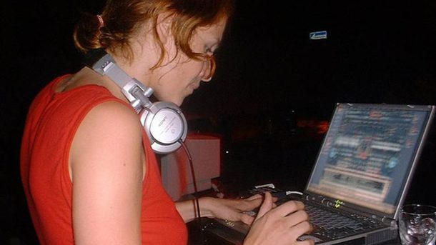](https://www.bonedo.de/fileadmin/_processed_/a/6/csm_05-History_Of_Native_Instruments_Traktor_die_Geschichte_von_Traktor_Scratch_Pro_b3115294f7.jpg)

*Bonedo author Manou was one of the first DJs to play only in the trendy clubs with a tractor and laptop. (Image: courtesy of Manuela Krause)*

### teething problems

“At the beginning, tractor wasn't hype. The idea of ​​bringing DJ software onto the market was definitely a brave one, ”concludes Becker.

“The first users were people who wanted to have a hang-up experience at home for little money, especially since little music was available digitally at all. There was a parallel development of MP3 format and DJ software, which is why we initially had a function for CD playback. At the beginning we were not taken seriously by the professional DJs. A computer in the DJ booth was pretty daring in the early nineties. Back then there wasn't even Ableton. "

At the time, virtual instruments were more accepted than DJ software because the computer in the studio was not a foreign body. Generally there were many compromises anyway. Due to the comparatively small storage space in computers, many MP3s still had low resolutions such as 128 kBit and then there was the question of where the MP3 actually came from. Before iTunes and Beatport, a lot of music came to the computer via Napster and other semi-legal sources. But the technical development and the time played into the hands of the Berlin software company like in the development of native plug-ins.

[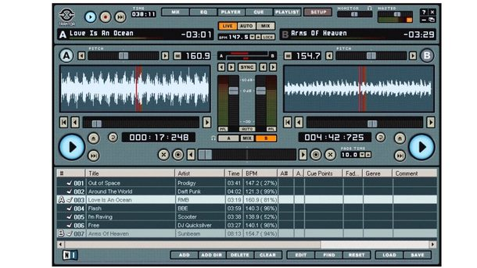](https://www.bonedo.de/fileadmin/_processed_/0/5/csm_06-History_Of_Native_Instruments_Traktor_die_Geschichte_von_Traktor_Scratch_Pro_84802ff649.jpg)

*Traktor DJ Studio was the first incarnation of Traktor and the beginning of a success story for DJ software (Image: courtesy of Native Instruments)*

### Embedded player

Traktor DJ Studio was pure PC software, but it wasn't limited to computers. In cooperation with Sony Records, there was an additional tractor DJ mix on several [Dream Dance Compilations](https://www.discogs.com/de/Various-Dream-Dance-27/release/218673) and on the Kai [Tracid album "Trance & Acid](https://www.discogs.com/Kai-Tracid-Trance-Acid/master/35990) " in 2002 , which was available as a small, compact mix file on the CD and accessed the audio tracks on the CD , This could be played on the Windows PC with the free included tractor player or of course with the full version of Traktor DJ Studio. The author of these lines also had the honor at the end of 2001, with the help and guidance of Friedemann Becker [himself,](https://www.discogs.com/de/Mijk-Van-Dijk-Everyground/release/68933) for his [album “Everyground](https://www.discogs.com/de/Mijk-Van-Dijk-Everyground/release/68933)“To create such a mix. With the digital "Automation Mix Recorder" - an integral part until the release of Traktor Pro in October 2008 - only the digital processes were recorded and were editable, playable and could be exported as audio files.

DJ mixes could even be created gradually in several sessions. At that time, hard drives were still relatively small and a WAV file, possibly several gigabytes in size, was still an imposition for every laptop. Here, too, NI tried out new innovative approaches early on, even if some of them ended in a cul-de-sac or later became obsolete due to the advancing technical development.

Friedemann Becker: “At some point we had to drop the Automation Mix Recorder because it was unexpected. With every new version of Traktor we had to drag along all old effects and all old workflows so that old recordings could be played on newer versions and sounded identical. At some point it became too much effort, it became unstable and the operation was never really pleasant to use. The first recording continuously, no problem, but editing mixes afterwards - the real meaning of this feature - was quite complicated. In the meantime, larger hard drives had found their way into the laptops of the users, longer WAV recordings were no longer a problem, so that we were finally able to part with the Automation Mix Recorder in favor of other priorities at Traktor Pro. ”

[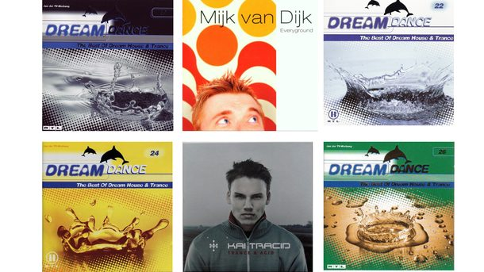](https://www.bonedo.de/fileadmin/_processed_/9/5/csm_07-History_Of_Native_Instruments_Traktor_die_Geschichte_von_Traktor_Scratch_Pro_6211c3fa91.jpg)

*Die erste Version von Traktor DJ Studio gab es auch als reinen Player für den PC. Einige Techno- und Trance-CDs beinhalteten einen Installer und ein Mixfile, das ausschließlich mit Traktor oder dem Traktor Player abspielbar war. (Bild: Mijk van Dijk)*

### Traktor DJ Studio 2 (Oktober 2002) – Ganz nah dran am User

Schon im Oktober 2002 kam Traktor DJ Studio 2 in die Läden, endlich auch als Mac-Version, zusammen mit vielen neuen Features wie Keylock, mehr Loop-Funktionen, Preview-Player sowie einem kräftigen Re-Design. Der Sync-Button saß jetzt groß und prominent unter den Playern.

„Bei der zweiten Version vom Oktober 2002 sieht man dann schon die Tendenz, von einer ganz klaren einfachen Applikation zu einem relativ komplizierten Studioprojekt zu wachsen“, schmunzelt Friedemann Becker beim Blick auf den Screenshot. „Da kamen dann immer mehr User-Wünsche dazu und damals ist Traktor sehr nah am User entwickelt worden. Die Nutzer äußerten viele Ideen und Wünsche, die wir gerne zur Verfügung stellen wollten. Deshalb hat Traktor zu jener Zeit sehr viele Features bekommen, die auch teilweise sehr unterschiedliche Bereiche abdeckten.“

[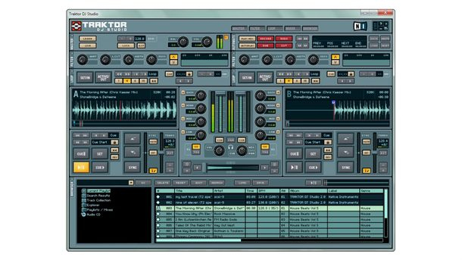](https://www.bonedo.de/fileadmin/_processed_/c/4/csm_08-History_Of_Native_Instruments_Traktor_die_Geschichte_von_Traktor_Scratch_Pro_67926c3758.jpg)

*Traktor DJ Studio 2 brachte gerade mal ein Jahr später eine Fülle neuer Features, viele angeregt von der stetig wachsenden User-Community (Bild: mit freundlicher Genehmigung von Native Instruments)*

### Traktor DJ Studio 2.5 (September 2003) – Beatjump und Key Control

Friedemann Becker: „Traktor DJ Studio 2.5 war dann eher ein kleines Update mit einem vertikalen Mixer, damit die Wellenformen schön viel Platz hatten. Die waren für immer mehr Leute richtig wichtig. Ich erinnere mich an lange Diskussionen, wenn wir mal das Farbschema verändert hatten: Die User beschwerten sich, dass sie „ihre Beats“ nicht mehr sehen konnten. Darum haben wir bei der Einführung der farbigen Wellenformen immer noch die Option belassen, die Wellenformen im gewohnten alten gelblichen Farbton anzuzeigen. Die farbigen Wellenformen sind übrigens tatsächlich frequenzbasiert, während wir bei Traktor DJ Studio 2.5 die Tönung noch über andere Faktoren erzeugt haben.

Then this variant also offered OSC (Open Sound Control), which is a kind of "high-resolution MIDI" with the disadvantage that it is not standardized. Reaktor runs with OSC and the plan was, among other things, to better connect the tractor and the reactor. Some video software also uses OSC. However, we did not pursue this excursion anymore because OSC is very special. "

[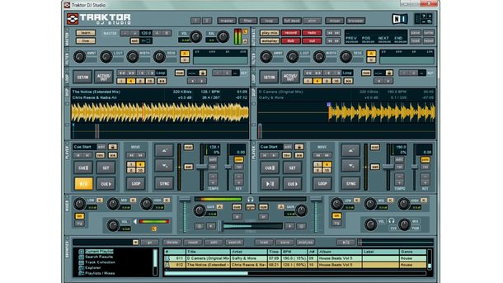](https://www.bonedo.de/fileadmin/_processed_/3/a/csm_09-History_Of_Native_Instruments_Traktor_die_Geschichte_von_Traktor_Scratch_Pro_d7cc15be5a.jpg)

*Traktor DJ Studio 2.5 offered the "Beatjump" function for the first time and, via key control, the stepless pitch change of a track (Image: courtesy of Native Instruments)*

In Sync Traktor, it was a pioneer for digital DJing in many areas. Not only that software and hardware companies like Pioneer have successively adopted concepts from Traktor like Beatjump and Deck Lock: Especially in the tiresome discussion about the sync button, Native Instruments anticipated many battles that other companies did not have to fight later , How did you perceive this discussion at NI?

"That was pretty blatant," Friedemann Becker admits frankly. “But respected DJs like Chris Liebing were very fascinated by the digital DJing and took sides for the sync button. This is just not a "replacement for the DJ", but would support and strengthen its possibilities. That helped us a lot in terms of credibility. Chris also suggested a four-channel version of Traktor early on. It was all before the vinyl control and it was also the hardest time for us. When Vinyl Control, Richie Hawtin and John Acquaviva came around the corner, many professional DJs finally saw Traktor as a serious alternative. ”

### Traktor Final Scratch (March 2004) - Scratch it!

In November 1998, the Amsterdam-based company N2IT presented the first timecode-based digital vinyl system (DVS) at COMDEX in Las Vegas: "Final Scratch" ran under BeOS and the hand-soldered hardware prototype was still in an aluminum can. The system was subsequently also seen in Germany, for example at the [Computer Chaos Camp](https://chaosradio.ccc.de/ctv114.html) (CCC) in 1999 in Paulshof Altlandsberg, 25 km northeast of Berlin.

There was no music on the specially pressed vinyl records, but a digital timecode signal that told the software via pickup and special sound card how fast the record was spinning and at which position it was located. Thus DJ was able to pitch and scratch a digital piece of music and also put the needle in the middle of the track like with an analog record. The software did not yet have a user-friendly interface, but it worked! For the first time, music files [could be checked](http://www.bedope.com/BeDC99/14.jpg) on a computer using [timecode vinyl records](http://www.bedope.com/BeDC99/14.jpg) .

The two Plus 8 label owners Richie Hawtin and John Acquaviva recognized the potential of this new technology and entered the Dutch developer company N2IT as a partner. The two star DJs publicly searched for partners for the necessary road-ready audio interface, also had contact with Native Instruments, but Stanton was awarded the contract and in early 2002 Stanton Final Scratch FS 1.0 was presented at the NAMM. The software ran under BeOS and Linux, still came from N2IT and looked very simple: two yellow waveforms on a blue background, a browser and that's it. No faders, no buttons and no sync. The circular “scratch amp”, which was connected to the computer via USB, served as the sound card.

Friedemann Becker remembers: “We had previously had discussions with Stanton about hardware. B. whether you don't even want to build a mixing controller for us. Now they came up to us and asked if we could make Traktor final scratch capable. This is how the first version of Traktor Final Scratch was created. But for that we had to put in real development work again. So we developed a new timecode and decoder that delivered better performance. With the new, very robust code, fast backspins and very slow scratches were now possible and the susceptibility to dust and interference signals was reduced. Above all, the fact that the software was finally available for Mac and Windows computers brought the breakthrough for Final Scratch. ”

Final Scratch FS 1.1 kam im März 2004 mit Traktor-typischem Interface zunächst für Linux und MacOS auf den Markt. Ab FS 1.5 war Schluss mit Linux und die Software setzte auf MacOS und Windows XP. Nun war auch hier Keylock möglich: Die Platte konnte bei unveränderter Tonhöhe in der Geschwindigkeit verändert werden. Aber nach wie vor gab es keinen Sync, hier durfte DJ per Control-Vinyl Hand anlegen.

Zeitenwende Zu jener Zeit wurden DJs von den Labels schon häufig mit MP3s statt Vinyl-Schallplatten bemustert, um die Promokosten niedrig zu halten. Viele DJs legten daher bereits mit einem Mix aus Vinyl und CD auf, aber DJ-CD-Player waren Anfang des neuen Millenniums noch verpönt und weit entfernt von den heutigen Möglichkeiten. So erschien ein System wie Traktor Scratch – auch dank des Supports durch Heavyweights wie Hawtin/Acquaviva – für vielreisende professionelle DJs sehr attraktiv, um viel mehr Musik auf Tour zu nehmen, als in eine oder zwei Plattenkoffer hineinpasst.

Für Hip-Hop Scratch-DJs tat sich ebenfalls ein völlig neues Feld auf. Endlich waren sie nicht mehr allein auf gepresstes Spezial-Vinyl oder schwer zu scratchende, kurzlebige Dubplates angewiesen, sondern konnten via DVS beliebige Soundfiles vom Computer einsetzen, z. B. Vocal-Spuren ihrer MCs und eigene kreierte Sounds. Und dass die Software noch nicht über das Sync-Feature verfügte, spielte hier keine Rolle. Friedemann Becker: „Beim Hip Hop DJ ist es ganz wichtig, die Scratch Skills auch zeigen zu können, ein eigentlich nicht dafür gedachtes Tool, wie einen Plattenspieler als Musikinstrument zu nutzen. Da ist Innovation fast schon kontraproduktiv, denn man will ja gar nicht, dass einem die Technik das abnimmt, sondern möchte seine Fingerfertigkeit unter Beweis stellen und als Scratch-Artist nachvollziehbar bleiben.“

Wer noch mehr zur Theorie des Timecodes erfahren möchte, findet bei [Wikipedia](https://en.wikipedia.org/wiki/Final_Scratch#Vinyl/CD_time_code) eine gute Beschreibung.

[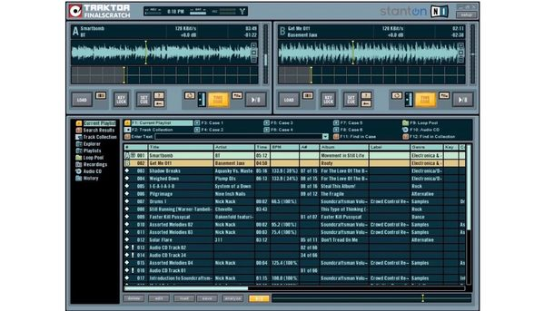](https://www.bonedo.de/fileadmin/_processed_/9/e/csm_10-History_Of_Native_Instruments_Traktor_die_Geschichte_von_Traktor_Scratch_Pro_d64b7c1c7c.jpg)

*Traktor Final Scratch war eine eigens entwickelte Software für Stantons Final Scratch. Zuerst noch als eigenständiges Produkt geführt, bot Traktor damit das Mixen via Kontroll-Vinyl an. (Bild: mit freundlicher Genehmigung von Native Instruments)*

### Traktor DJ Studio 2.6 (November 2004)

Das DJ-Studio mit Vinyl-Kontrolle Nach wie vor war Traktor Final Scratch eine eigenständige und unabhängige Software. Parallel dazu entwickelte Native Instruments das Traktor DJ Studio weiter. Mit Version 2.6 wurde auch Traktor DVS-fähig. Das war eine wichtige Sache, denn dadurch wurde das Traktor-Hauptprogramm mit all seinen mächtigen Funktionen zur Konkurrenz für das relativ simple Final Scratch. Unter anderem wurde die Final Scratch-Technologie dadurch Sync-fähig und es war möglich, trotz Vinyl-Kontrolle Tracks zu loopen. Dazu kam, dass der Track nicht mehr ausschließlich „absolut“ an den Timecode gebunden sein musste, sondern auch „relativ“ lief.

Außerdem führte NI mit dieser Version den Audiorecorder ein, um Mixe nicht nur als Daten per Mixrecorder, sondern auch direkt als Audiofile aufnehmen zu können, unerlässlich beim Betrieb mit Kontroll-Vinyl. Zusätzliche File-Formate wie FLAC, Ogg Vorbis, AAC und WMA gesellten sich zu MP3, WAV und AIFF.

Und schließlich schuf man mit „Conditional MIDI Mapping“ die Grundlage für eine höchst kreative Mapping-Scene, die Traktor in den Folgejahren zur wichtigsten Software für DJ-Controller machen sollte. Plötzlich gab es einen neuen Begriff: Controllerism, vor allem lanciert von der US-amerikanischen Website DJtechtools und deren Gründer Ean Golden, die unter anderem viele Mappings für alle möglichen und unmöglichen Controller zum kostenlosen Download anboten.

Friedemann Becker: *“Ean Golden has achieved a lot. I don't know if it was he who came up with the term "controllerism", but he promoted it very strongly as a new category with his website DJtechtools. In addition to turntablism, controllerism was accepted and introduced as a new category even at the DMC championshots. Then there were the many different mappings that could be downloaded from DJTT, as well as the overlays and ultimately the hardware that Ean developed itself. ”*

With the blessing of Vestax, Ean sold his own version of the VCI-400, created the Dicer Mini-Controller for Novation and the MIDI Fighter series on his own.

[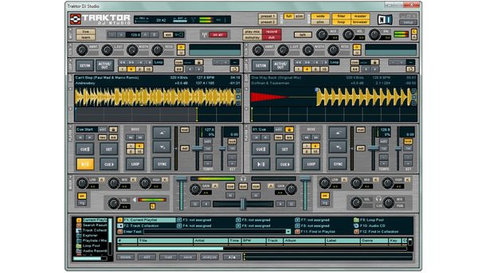](https://www.bonedo.de/fileadmin/_processed_/7/d/csm_11-History_Of_Native_Instruments_Traktor_die_Geschichte_von_Traktor_Scratch_Pro_bb1c21043a.jpg)

*Traktor DJ Studio 2.6 made Traktor DVS capable. All the powerful tractor functions were now also available to vinyl DJs. (Image: Courtesy of Native Instruments)*

### Tractor 3 (September 2005) - Four decks and more

Native Instruments expanded its DJ software even further with Traktor 2: Now there were four decks, effects and even a dedicated on-board browser for the recently launched Beatport store, in which NI owned shares. Now the GUI was completely overloaded with functions and DJ could even configure the user interface himself using the configurable header panel. And everything could be controlled either via MIDI controllers or timecode vinyl.

Friedemann Becker: "In the meantime, we no longer found the name" Studio "to be applicable because tractor had become a stage tool, so we omitted it from this version. Traktor 3 offered the high point in the configurability of the user interface. In my opinion, this never happened again, we had so many functions and it was necessary to offer a rack in the header panel where you could plug in different modules so that the GUI did not explode completely. Since there were only four decks starting with Traktor 3, the main reason is that laptops only had enough CPU power in 2005 to process all the tractor features in four ways. Key-Lock in particular is very "expensive" when it comes to CPU consumption. "

### Beatport Inside

"The Beatport integration, on the other hand, was an excursion that we did not pursue after tractor 3," continued Becker. “NI was a partner and we supported Beatport with our know-how in their initial phase. The company even initially had its office on our premises. Then the idea of ​​an embedded Beatport window in the browser came up. Unfortunately, concepts such as "responsive design" did not yet exist at that time, so Beatport had to maintain two shop frontends, the one in Traktor 3 and the one on the web. The latter was, of course, always more up-to-date, which is why customers ultimately always bought in the online shop. The intensity of use and the effort simply did not pay off for us. But the idea was basically good and maybe it will come back someday,

[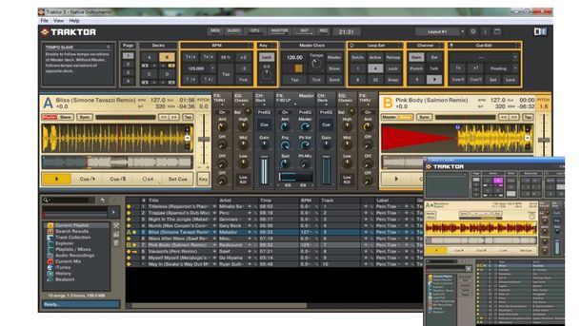](https://www.bonedo.de/fileadmin/_processed_/7/d/csm_12-History_Of_Native_Instruments_Traktor_die_Geschichte_von_Traktor_Scratch_Pro_a9753a00bf.jpg)

*Traktor 3 bot einen unglaublich großen Funktionsumfang, mit vier Decks und sogar mit eingebettetem Beatport-Shop, allerdings zum Preis der maximalen Unübersichtlichkeit. So vollgestopft war das GUI von Traktor danach nie wieder. (Bild: mit freundlicher Genehmigung von Native Instruments)*

### Traktor Final Scratch 2 (November 2005) -Noch einmal gemeinsam

In der Zwischenzeit entwickelte Stanton den Scratch Amp 2, der ein wenig wie ein Car-HiFi-Verstärker aussah, per Firewire verbunden wurde und im November 2005 zusammen mit Traktor Final Scratch FS 2.0 auf den Markt kam. Von der Firewire-Schnittstelle versprach man sich weniger Latenz als mit USB 1.0. Der Scratch Amp 2 funktionierte nicht ausschließlich nur mit Final Scratch 2, sondern war auch kompatibel zu den damals aktuellen Traktor Versionen, z. B. Traktor DJ Studio 3 ab Version 3.3. Und so gab es für Stanton neben Serato eine weitere Konkurrenz: Native Instruments selbst. NI hatte einen eigenen Timecode (MK2) entwickelt, der mit dem ursprünglichen Final Scratch-Timecode abwärtskompatibel war: Mk1 Control Vinyls konnten z. B. nach wie vor genutzt werden. Friedemann Becker erinnert sich: „Es kam der Punkt, an dem wir dem Timecode ein Update geben wollten, um ihn noch robuster zu machen. Da dieser MK2 Timecode eine Neuentwicklung war und aus unserer Sicht auch nicht die Patente der Firma N2IT verletzte, stellten wir die Lizenzzahlungen ein. Dies führte zu einem Rechtsstreit mit Stanton, an dessen Ende ein Vergleich stand und Native Instruments die gesamten Patente am Timecode erwarb.

Ein Aspekt, der mich persönlich sehr stolz gemacht hat, war, dass viele der schlauen Köpfe aus der digitalen Computer-Technologie im Laufe der Zeit zum Traktor gestoßen sind. Da war Jim Mazur, der Kopf hinter Final Scratch bei Stanton, der 2007 zu uns stieß und bis 2017 die Traktor Brand geleitet hat und Chad Carrier, der Macher hinter M-Audios DJ Software Torq, die viele richtungsweisende Features als erste vorstellten. Chad war bei NI lange Jahre Product Owner für Traktor und leitet inzwischen eines der Maschine Teams."

[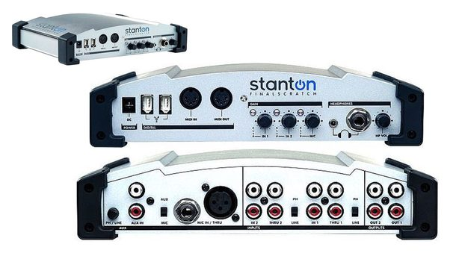](https://www.bonedo.de/fileadmin/_processed_/b/0/csm_13-History_Of_Native_Instruments_Traktor_die_Geschichte_von_Traktor_Scratch_Pro_d0806d5218.jpg)

*Traktor Final Scratch 2 kam mit dem neuen Scratch Amp 2, einer leicht überdimensionierten Firewire-basierten Soundkarte mit zusätzlichem Mikrofoneingang. (Bild: mit freundlicher Genehmigung von Native Instruments)*

### Traktor Scratch (Januar 2007)- Getrennte Wege

Schon im Januar 2007 stellten die Berliner Traktor Scratch vor, sozusagen die Fortführung von Traktor Final Scratch unter eigener Flagge und mit eigenem Audiointerface, dem Audio 8 DJ. „Endlich haben wir dann auch mal eigene Hardware gemacht“, stellt Friedemann Becker mit erkennbarer Zufriedenheit fest. „Vorher hatten wir immer viele Kooperationen mit anderen Partnern, aber hier haben wir schließlich unsere eigenen Ideen verwirklichen können. Allen voran natürlich die Audio 8 DJ. Es gab vorher natürlich schon Standard-Soundkarten für Traktor, aber die waren alle nicht so optimal. Für den kleinen Geldbeutel stellte [NI Traktor Scratch Duo](https://www.bonedo.de/artikel/einzelansicht/traktor-scratch-duo.html) vor, eine zweikanalige Variante der großen Software mit der passenden Audio 4 DJ-Soundkarte.

[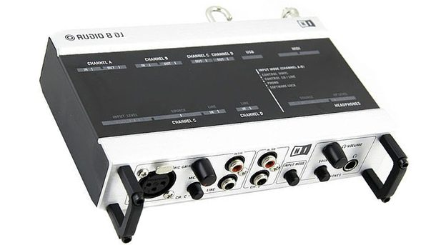](https://www.bonedo.de/fileadmin/_processed_/d/c/csm_14-History_Of_Native_Instruments_Traktor_die_Geschichte_von_Traktor_Scratch_Pro_0068598863.jpg)

*Traktor Scratch war die eigene Variante von Final Scratch, die Native Instruments nach der Trennung von Stanton herausbrachte. Mit dabei, die Audio 8 DJ Soundkarte, die immer noch klaglos bei vielen DVS-DJs ihren Dienst tut. (Bild: mit freundlicher Genehmigung von Native Instruments)*

### Traktor Pro (Oktober 2008) – Vieles auf Anfang

Mit Traktor Pro und der teureren DVS-Variante [Traktor Scratch Pro](https://www.bonedo.de/artikel/einzelansicht/native-instruments-traktor-scratch-pro.html) setzte Native Instruments seine Software neu auf. Die neue User-Interface-Abteilung hatte die überladene Oberfläche von Traktor 3 wieder übersichtlicher gestaltet, Traktor Pro sah schon vor 10 Jahren ungefähr so aus, wie wir es heute immer noch kennen. Dazu wurde das Software-Innenleben kräftig entrümpelt, alte Routinen wurden rausgeschmissen und Traktor Pro war nicht mehr kompatibel zu seinen Vorgängern. Manchen Anwender hat das gestört, aber die stabile Engine, der neue Look und nicht zuletzt so kleine, aber feine Neuerungen wie die Darstellung des Cover-Artworks versöhnten die Traktor-Gemeinde schnell wieder. Für viele DJs war die Anzeige der Cover ein großer Wurf. Endlich konnte man Playlisten auch visuell durchsuchen, fast wie beim Blättern durch die Plattenkisten wurde das oberste Viertel des Covers auch in den „Crates“ angezeigt. Neben der Wellenform wurde die Umdrehungsposition oder die Qualität der DVS-Verbindung angezeigt. Kleine Service-Updates wie [Traktor Pro 1.2](https://www.bonedo.de/artikel/einzelansicht/ni-update.html) brachten weitere Verbesserungen wie eine flexiblere Effekt-Sektion, optimiertes Time-Stretching, Display-Unterstützung für aktuelle Hardware-Controller und mehr.

Mittlerweile war DJ-Software der Standard in der DJ-Booth. Der Begriff „Serato-Face“ kam für DJs auf, die mehr in ihre Laptops als auf den Dancefloor starrten. Um den Fokus vom Computer zu entkoppeln, mussten DJs die Musik „anfassen“ können, beim Spielen, aber auch schon beim Auswählen. NI stellte mit dem [Kontrol X1](https://www.bonedo.de/artikel/einzelansicht/native-instruments-kontrol-x1.html) den ersten eigenen NI-Controller vor, mit Tasten und Reglern für Transport, Hot Cues, Loops, Browsing und Effekte. Ein kleines, geniales Hardcase brachte den flachen X1 auf gleiche Höhe mit den Turntables und dem Mischpult und fortan sah man viele DJs mit Scratch-Vinyl, die über den X1 durch ihre Playlisten browsten und Hot Cues, Loops und Effekte bedienten.

[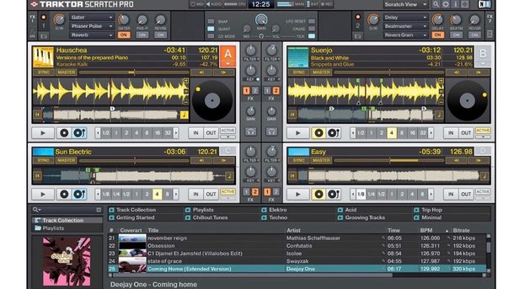](https://www.bonedo.de/fileadmin/_processed_/9/b/csm_15-History_Of_Native_Instruments_Traktor_die_Geschichte_von_Traktor_Scratch_Pro_a63e42a98e.jpg)

*Mit Traktor Pro und Scratch Pro renovierte NI das Traktor-Sortiment und definierte den Look, der auch heute noch gültig ist. (Bild: mit freundlicher Genehmigung von Native Instruments)*

### Traktor Pro S4 (Oktober 2010) – die Geburt der klassischen Controller-Console

With the Kontrol S4 controller with integrated sound card, NI finally presented an all-round carefree solution for all DJs who do not want to work with DVS. The first S4 is the best-selling tractor controller of all time and a role model for many consoles from other companies. The brand new Kontrol S4 MK3 also always follows the Mark 1 with its form factor. Four sample decks were integrated as delicacies into the tractor software, the forerunners of the Remix Decks with up to 64 samples. In the beginning, these were only available with the [Kontrol S4 hardware](https://www.bonedo.de/artikel/einzelansicht/native-instruments-traktor-kontrol-s4.html) and this caused displeasure among users, especially among the mapping community, who liked to use other controllers such as B. would have used the Novation Launchpad to control the sample decks.

Friedemann Becker asks for understanding: “Unfortunately, evil is often assumed quickly. At the time, this limitation was due only to the fact that it is something completely different to adapt a feature only for your own hardware or to make it mappable for any MIDI controller. We wanted to do our homework and get the feature to work in a controlled ecosystem before we opened it to everyone else, because then completely different quality standards apply. That will probably be more common in the future.

We had the remix decks in mind even then, but the step would have been too big at the time. The waveforms on the Pro S4 were also not yet colored. Overall, Pro S4 was an intermediate step that points to more, but not much has changed in the overall architecture since Traktor Pro.

The amount of new features also became less and less because more and more energy had to be invested in the maintenance and stabilization of this software on the constantly evolving operating systems.

With such old software, service is often the lion's share of the work: a new MacOS comes and suddenly the waveforms jerky and so on. We receive e.g. For example, Apple always gives beta versions of the new operating systems in advance, but sometimes there is always a decisive change in the last update before the release, so that you can only say whether the new operating system is really out only when it is out you are completely compatible or not. And this happens every year at Apple, with Windows there are only minor updates. But that definitely keeps us in suspense. "

[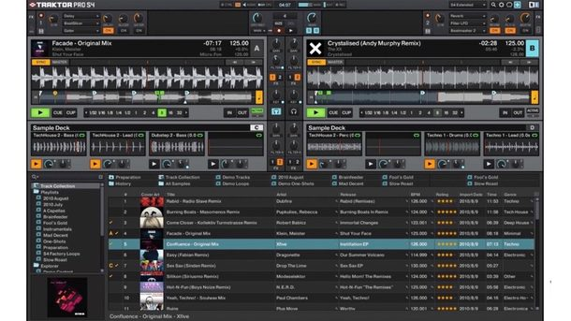](https://www.bonedo.de/fileadmin/_processed_/8/5/csm_16-History_Of_Native_Instruments_Traktor_die_Geschichte_von_Traktor_Scratch_Pro_a0b774e438.jpg)

*Traktor Pro S4 for the Kontrol S4 of the same name, the best-selling tractor controller ever. (Image: Courtesy of Native Instruments)*

Traktor Pro 2 (April 2011) - Everything so colorful here

In [Traktor Pro 2](https://www.bonedo.de/artikel/einzelansicht/native-instruments-traktor-pro-2.html) there were finally sample decks for all colored waveforms, the loop recorder as an intermediate step to the remix decks. All in all, Traktor was now very well formulated. What could "improve" at all now?

Friedemann Becker: “What can still be done better is stability and efficiency, so that the software gets an ever smaller footprint to give the computer more and more air to do its job. Most of the stability problems with software come from the fact that the program is “knitted on edge”, so that the computing time is not sufficient to calculate the audio that has to be played in real time. To install new features such as the STEM decks, the program had to get enough reserves, because in principle up to 16 stereo tracks had to be calculated in real time. It was only through computer development and internal optimizations that it was possible to implement as many tracks and something as the macro effects, where there are at least three effects per unit. The user sets the buffersize how many milliseconds it gives tractor time to calculate all the audio. This is the big challenge with real-time applications, in contrast to non-real-time programs like Photoshop. ”The DVS variant [Traktor Scratch Pro 2](https://www.bonedo.de/artikel/einzelansicht/native-instruments-traktor-scratch-pro-2.html)  brought the update of the Audio 8 DJ sound card with the Audio 10 interface. For less money, there was the two-channel version of the [Traktor Scratch Duo 2](https://www.bonedo.de/artikel/einzelansicht/native-instruments-traktor-scratch-duo-2-audio-6.html) with the Audio 6 sound card.

 Mittlerweile hatte sich Traktor zu einer superstabilen Software gemausert, die klaglos ihre Audiodateien abspielte, selbst wenn der Rechner am Rande der CPU-Last läuft. Friedemann Becker erläutert: „Wir haben einige Sicherheitsnetze eingebaut. Der Audiothread, der Prozess, in dem die Audioverarbeitung berechnet wird, genießt die oberste Priorität und wenn es da knapp wird, wird erst mal das User-Interface in der Priorität runtergefahren, dann wackelt unter Umständen mal die Wellenform oder das GUI bleibt hängen, aber die Musik läuft weiter. Es kann natürlich immer noch zu Fehlern bei der Audioausgabe kommen, wenn der User viele andere leistungshungrige Programme offen hat, dann kann auch Traktor dagegen nichts mehr tun. Wir haben leider keine Sonderrechte im System.“

[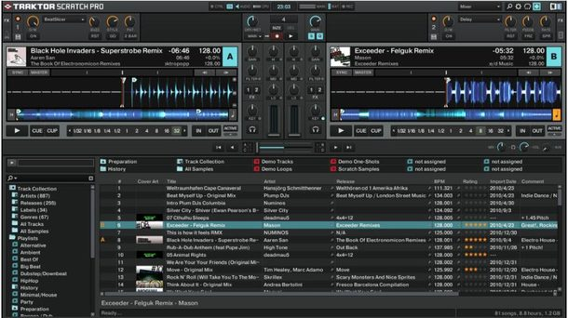](https://www.bonedo.de/fileadmin/Images/DJ_PA/Feature/History_Of_Traktor_die_geschichte_von_Native_instruments_Traktor_Scratch_Pro/17_Traktor_History.JPG)

*Traktor Pro 2 kam mit Sample Decks für alle, Loop Recorder und endlich farbigen Wellenformen. (Bild: Numinos)*

### Traktor Pro 2.5 (März 2012) – Remixen mit der Power der Vier

Mit Traktor 2.5 wertete NI die Sample-Decks zu den weitaus mächtigeren Remix-Decks auf. Loops aus den Trackdecks oder dem Loop-Recorder konnten nun gespeichert und nahtlos synchron zu den Trackdecks laufen, ein Track quasi on-the-fly geremixt werden. Dazu gab es wieder neue, passende Hardware: Mit dem Kontrol F1 lassen sich bis zu 64 Loops und One-Shot-Samples abfeuern. „Remix-Decks und F1 gehören eng zusammen, denn ohne den lassen sich die Remix-Decks nur schwer bedienen“, erklärt Friedemann Becker. „Es hat uns auch immer geholfen, dass wir uns strikt an diese Zahl „Vier“ gehalten haben. Das können vier Volumes sein, vier Stems, vier Remix-Cells. Es gibt einen roten Faden bei Traktor, [immer mit „Vierfachen“ zu arbeiten.](https://www.bonedo.de/artikel/einzelansicht/native-instruments-kontrol-f1.html)“

### Traktor Pro 2.6 (November 2012) – Kontrol Z2, das Beste beider Welten

With “four” it went with new hardware such as the two-channel [Battlemixer Kontrol Z2](https://www.bonedo.de/artikel/einzelansicht/traktor-kontrol-z2-test.html) further, who with his permanently installed Traktor Scratch-certified audio card turned mainly to hip hop DJs and provided them with four autocue buttons to combine turntablism and controllerism. The well-processed, full-fledged DJ mixer with XLR outputs, separate booth output and microphone input offers normal phono and line inputs for turntables and CDs, but turns into a comfortable tractor controller with browse- when connected to a laptop with a tractor connected via USB. Function, effect control, hot cues and even a triple USB hub for X1, F1 or simply a USB gooseneck lamp to illuminate the workplace. Still a good choice for DJs, even if they play mostly vinyl.

[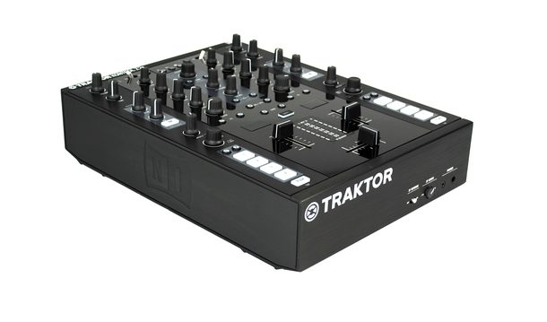](https://www.bonedo.de/fileadmin/_processed_/f/9/csm_Native_Instruments_Traktor_Kontrol_Z2_1_Teaser_de3d3184cf.jpg)

*The Kontrol Z2 tractor (Image: PW)*

### Traktor DJ (February 2013) - Traktor To Go

Long awaited, Native Instruments ported its digital DJ technology to the iPad in February 2013, the app was called [Traktor DJ](https://www.bonedo.de/artikel/einzelansicht/test-native-instruments-traktor-dj.html) and was also available for iPhone and iPod Touch shortly afterwards. DJ could now actually "touch" the music or the waveforms and operate the app with the typical gesture techniques. There was also a compact mixer with an integrated sound card that can be operated under both iOS and OSX: the [Kontrol Z1.](https://www.bonedo.de/artikel/einzelansicht/native-instruments-traktor-kontrol-z1-test.html)

 With the combination of Traktor DJ for iPad and the Z1, NI had a powerful and extremely mobile DJ system in their portfolio that refreshed the tractor philosophy and brought it back to its origins: two decks, EQ and filter, that's it. Suddenly even mobile DJing was possible, even before the portablism hype, as DMC champion DJ Shiftee shows in this beautiful promo video on the streets of Berlin.

[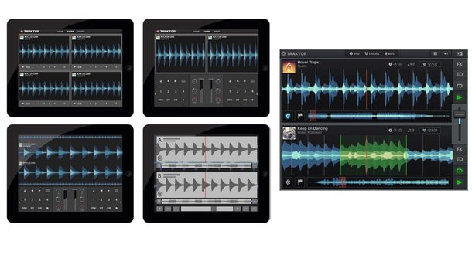](https://www.bonedo.de/fileadmin/_processed_/0/4/csm_19-History_Of_Native_Instruments_Traktor_die_Geschichte_von_Traktor_Scratch_Pro_3ffda55ecc.jpg)

*Traktor DJ brought Traktor technology to iPad and iPhone. (Image: Courtesy of Native Instruments)*

### Traktor Pro 2.9 (November 2014) - STEMS, a completely new DJ format

With the [STEM tracks](https://www.bonedo.de/artikel/einzelansicht/native-instruments-stems-und-traktor-pro-29.html)  , NI launched a highly interesting new audio format four years ago. There are four subgroups of a track in an MP4 file container, which are played like a normal stereo file, but can be individually adjusted in volume, filter and effect intensity by the DJ. The corresponding STEM tracks can be purchased from Beatport or from your own productions using the free [Stem Creator](https://www.bonedo.de/artikel/einzelansicht/stems-erstellen-mit-dem-native-instruments-stems-creator-tool.html) be generated. Purchased STEMS are mostly divided into drums, bass, melodic elements and vocals and effects. This gives DJ access to individual elements of the song. Thanks to a sophisticated software compressor from the NI modular system, STEM tracks sound almost as bold as the well-mastered stereo file despite their four individual tracks. The software came along with NI's next major hardware prank, the [Kontrol S8](https://www.bonedo.de/artikel/einzelansicht/native-instruments-traktor-kontrol-s8-test-1.html) , a lavishly sized luxury controller with two large, high-resolution color displays that is optimized for playing with STEMS. The more compact [Kontrol S5](https://www.bonedo.de/artikel/einzelansicht/native-instruments-traktor-kontrol-s5-test.html) and [Kontrol D2](https://www.bonedo.de/artikel/einzelansicht/native-instruments-traktor-kontrol-d2-test.html) came later the latter is a single player or add-on to the Kontrol Z2. But a STEM deck can only be controlled well with the Kontrol F1 remix deck controller.

[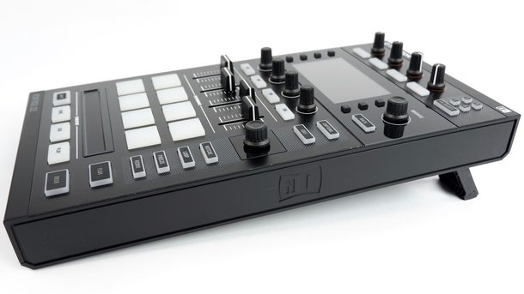](https://www.bonedo.de/)

*The Kontrol D2 is a very compact replacement for the remix deck control functions of the large Kontrol S8 for controlling Traktor Pro 2.9*

* [https://www.bonedo.de/fileadmin/_processed_/a/5/csm_20-History_Of_Native_Instruments_Traktor_die_Geschichte_von_Traktor_Scratch_Pro_7608e9c399.jpg](https://www.bonedo.de/)
* [https://www.bonedo.de/fileadmin/_processed_/7/1/csm_21-History_Of_Native_Instruments_Traktor_die_Geschichte_von_Traktor_Scratch_Pro_351c0ec7d6.jpg](https://www.bonedo.de/)

### Four is the magic number

How did Native Instruments come up with the number of four tracks on the stem decks? ”“ A very strong drive was that we always had “four” and that the usability of the hardware remains manageable. We clearly knew that you always have to make compromises, not every track can be separated into four logical stems without combining tracks. We had a long discussion between the numbers four, five and six and at the end of the day we came up with the "four" mainly because of the hardware. It was important for us that the STEM decks remain operable in a mobile hardware controller setup and that our DJ software does not drift too much in a DAW direction. In addition, such a producer did not have to reveal his individual tracks too much,

### STEMS and how to proceed

How exactly DJ works with STEMS was not clear to many despite informative Bonedo crash courses and the STEM tracks are still a niche existence - loved by some, ignored by most. NI had hoped a lot from the [STEMS format](https://www.bonedo.de/artikel/einzelansicht/native-instruments-stems-und-traktor-pro-29.html) and disclosed the format, so that other companies can also make STEMS playable on their devices - unfortunately so far to no avail.

Friedemann Becker is surprised: “It is quite paradoxical, there are a lot of DJs who find the format incredibly interesting and wonder why it is not widely used. We are trying hard, we have z. For example, they also spoke to artificial intelligence companies about whether they didn't want to use the STEMS format because they think and work in more layers and dimensions than the ordinary DJ anyway. Many DJs also say that it's actually an undiscovered pearl. It is child-easy to play with a STEM, because you actually don't have to do more than a track. You can either just do nothing at all, but you also have the opportunity to go deep. By dividing it into four tracks, STEM tracks are the ultimate EQ because not only about frequencies, but can directly isolate the sounds via tracks without destroying the timeline. It is a pity that there is not much more content for STEMS. Unfortunately, all STEMS files produced so far are still a drop in the ocean when you look at the entire music repertoire of the world. This becomes even more difficult with older music, of which there are probably no files from which the STEMS could then be generated. So it is difficult to make the content of the DJs available in STEMS. So it's been a new tool so far, rather than a new format. It would of course be fantastic if you could split stereo files in a stem creator into four separate tracks so that you can extract your four stems from each track. that there is not much more content for STEMS. Unfortunately, all STEMS files produced so far are still a drop in the ocean when you look at the entire music repertoire of the world. This becomes even more difficult with older music, of which there are probably no files from which the STEMS could then be generated. So it is difficult to make the content of the DJs available in STEMS. So it's been a new tool so far, rather than a new format. It would of course be fantastic if you could split stereo files in a stem creator into four separate tracks so that you can extract your four stems from each track. that there is not much more content for STEMS. Unfortunately, all STEMS files produced so far are still a drop in the ocean when you look at the entire music repertoire of the world. This becomes even more difficult with older music, of which there are probably no files from which the STEMS could then be generated. So it is difficult to make the content of the DJs available in STEMS. So it's been a new tool so far, rather than a new format. It would of course be fantastic if you could split stereo files in a stem creator into four separate tracks so that you can extract your four stems from each track. when you look at the entire music repertoire of the world. This becomes even more difficult with older music, of which there are probably no files from which the STEMS could then be generated. So it is difficult to make the content of the DJs available in STEMS. So it's been a new tool so far, rather than a new format. It would of course be fantastic if you could split stereo files in a stem creator into four separate tracks so that you can extract your four stems from each track. when you look at the entire music repertoire of the world. This becomes even more difficult with older music, of which there are probably no files from which the STEMS could then be generated. So it is difficult to make the content of the DJs available in STEMS. So it's been a new tool so far, rather than a new format. It would of course be fantastic if you could split stereo files in a stem creator into four separate tracks so that you can extract your four stems from each track.

[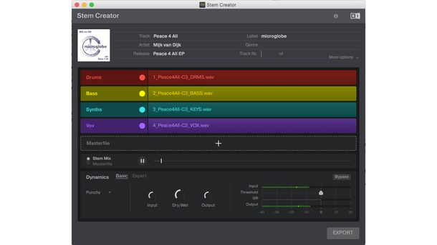](https://www.bonedo.de/fileadmin/_processed_/7/1/csm_22-History_Of_Native_Instruments_Traktor_die_Geschichte_von_Traktor_Scratch_Pro_0eed2843d2.jpg)

*With the free Stem Creator, producers can create their own stems. (Photo: Mijk van Dijk)*

Bonedo: Would it be technically conceivable that, similar to the [Accusonus software Regroover,](https://www.bonedo.de/artikel/einzelansicht/accusonus-regroover-pro-test.html) sometime in the future Traktor could generate four separate stem files from each stereo [music file](https://www.bonedo.de/artikel/einzelansicht/accusonus-regroover-pro-test.html) ?

Friedemann Becker: “I think it has to go there. That is so close and so obvious. That's what neural networks do today. A highly complex algorithm is released on the music, which then extracts individual tracks from a wide variety of criteria that have been learned, and this is guaranteed to get better and better through a continuous learning loop. It's all just a matter of computing power. In the case of the DJ system, it doesn't even matter that the channels are separated completely, because you always work in a mix anyway. So if I have a little whisper from the vocals on the extracted bass drum, but it is faded in musically acceptable, then we actually have the result that we need. I wouldn't be surprised if this format is still experiencing a revival, when the algorithms are so far that during an analysis - similar to the beat grid analysis - Traktor also extracts the stems. There are quite a few companies that are working in this direction that focus even more on vocal and drum extraction, but it's all just a question of attitude. I'm optimistic about it. "

The last years of Traktor 2 From then on, Traktor stayed on version 2. Small service updates appeared, some with powerful features like [Traktor Pro 2.11](https://www.bonedo.de/artikel/einzelansicht/hands-on-native-instruments-traktor-pro-211.html) , which is a small, fine four-track step sequencer for the remix decks, Ableton Link Support, HID - Integration for Pioneer CDJ-2000NXS2 and Traktor Scratch certification for Pioneers DJM-900NXS2 and Allen & Heaths XONE: PX5 brought.

Meanwhile, Pioneer conquered [the DJ booth](https://www.bonedo.de/artikel/einzelansicht/dj-hardware-vs-dj-software-schluss-mit-laptop.html) with the current [CDJs and record box](https://www.bonedo.de/artikel/einzelansicht/dj-hardware-vs-dj-software-schluss-mit-laptop.html) , also thanks to a large investment of over half a billion dollars that the private equite company KKR (Kohlberg Kravis Roberts) pumped into Pioneer DJ in 2015. Native Instruments also got [some fresh money](https://www.bonedo.de/artikel/einzelansicht/pioneer-ni-und-die-50-millionen-native-instruments-stellt-sich-fuer-die-zukunft-auf.html) in October 2017  and the first results are now being presented: In [April 2018, Native announced new tractor software and controllers. The](https://www.bonedo.de/artikel/einzelansicht/native-instruments-kuendigt-neue-traktor-version-und-neue-hardware-an.html) time was ripe for change.

[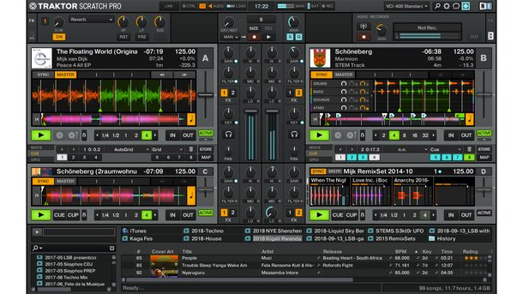](https://www.bonedo.de/fileadmin/_processed_/a/c/csm_23-History_Of_Native_Instruments_Traktor_die_Geschichte_von_Traktor_Scratch_Pro_59e7a84da0.jpg)

*Traktor 2.11 at its best: Track decks, STEM decks, remix decks, all in sync. (Photo: Mijk van Dijk)*

In the next part of the great Traktor history: Traktor Pro 3, how it came about and what will come.

<https://www.bonedo.de/artikel/einzelansicht/interview-nis-friedemann-becker-ueber-den-kontrol-s4-mk3-traktor-pro-3-und-die-zukunft-von-dvs-und-traktor.html>

# Interview: NIs Friedemann Becker about the Kontrol S4 MK3, Traktor Pro 3 and the future of DVS and Traktor

## History and Future of Native Instruments Traktor Teil 2

von [Mijk van Dijk](https://www.bonedo.de/autor/information/mijk-van-dijk.html)

11.12.2018

[1](https://www.bonedo.de/artikel/einzelansicht/interview-nis-friedemann-becker-ueber-den-kontrol-s4-mk3-traktor-pro-3-und-die-zukunft-von-dvs-und-traktor.html#commentbox) [81](https://www.bonedo.de/?type=1249059875&tx_bonedo_ajax%5baction%5d=likeArticle&tx_bonedo_ajax%5barticle%5d=18923)

[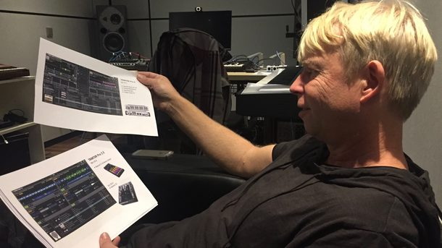](https://www.bonedo.de/fileadmin/_processed_/7/e/csm_06_Traktor-History2_08ed453446.jpg)

*Traktor Product Owner Friedemann Becker explains the new Traktor Pro 3 and gives an outlook on the future*

Alongside Serato, Native Instruments Traktor is the most important professional DJ software. Whether mixing only with the laptop, with DVS support or our own highly specialized controllers: Traktor has decisively shaped and promoted the image of the digital DJ and innovations such as loops, beat jump, remix decks, stem decks and last but not least the infamous sync button in introduced the DJ culture. On the occasion of the release of Traktor Pro 3 and the brand new controllers Kontrol S4 MK3 and Kontrol S2 MK3, Bonedo met the person at NI who accompanied Traktor from the beginning: Traktor Product Owner Friedemann Becker.

After [looking back on two decades of digital DJing](https://www.bonedo.de/artikel/einzelansicht/native-instruments-traktor-evolution-der-dj-software.html)  , Becker is now looking ahead, explains Traktor Pro 3, how it came about and what else is coming.

### New controller, new luck

Traktor Pro 3 is here. And don't come alone: ​​there is a new, innovative hardware controller: the Kontrol S4 MK3 with motorized jog wheels, the so-called “haptic drives”, which are intended to convey an authentic vinyl feel. In the NI headquarters I was able to work on a Kontrol S4 MK3 with firmware version 0.4.5 before the release.

I don't want to anticipate the Bonedo test here, but I won't withhold my first impressions after unpacking the device, because the new tractor controller is really fun. It feels nice and valuable, and my skepticism about the motorized jog wheels quickly evaporated. They actually turn and have a lot of power behind them - magnetic force makes it possible.

The controller is not particularly heavy, but larger than its predecessors S4 and S5 and looks much more valuable. I don't necessarily share the NI soft spot for the mix of materials between glossy and matt, but the S4 MK3 makes a solid, sober and professional impression in terms of design and feel, also because the colorful RGB pads are more subtly illuminated. Solid quality! The new arrangement of the controls nods a bit towards the Pioneer, but after the Japanese have already learned so much from the Berliners, they can now.

[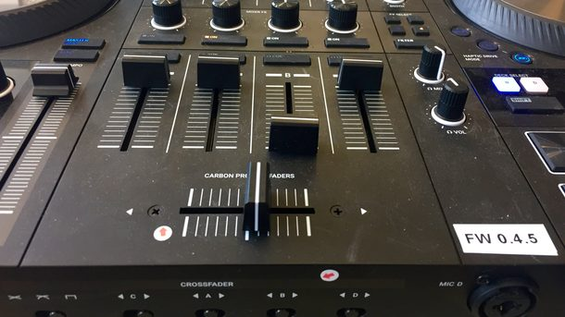](https://www.bonedo.de/fileadmin/_processed_/5/2/csm_03_Traktor-History2_e813a3aedd.jpg)

*Firmware 0.4.5: This Traktor Kontrol S4 MK3 prototype couldn't do all the tricks yet, but a hell of a lot*

NI has refrained from the large displays, and rightly so, because if you already carry your laptop with you, you can also look at it and do not necessarily need an additional mouse cinema. The now smaller displays, on the other hand, provide important information about the game status of the track clearly where the DJ needs it: right in front of your nose. A good decision.

I really enjoyed the small, fine step sequencer. [Introduced with no big fuss with version 2.11](https://www.bonedo.de/artikel/einzelansicht/hands-on-native-instruments-traktor-pro-211.html) , the step sequencer always stayed a bit under the radar. In my short test mix, there were four 808 drums on the step sequencer, bass drum, snare and hi-hats and in no time a simple supporting beat loop was programmed. In some DJ situations this can be worth gold. Everything else follows in the test

[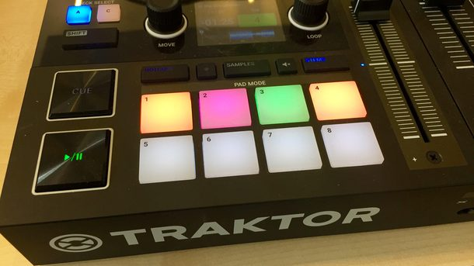](https://www.bonedo.de/fileadmin/_processed_/2/f/csm_04_Traktor-History2_5e2fcdea4e.jpg)

*The tractor step sequencer has been a shadowy existence up to now. There is hope that these days are finally over: thanks to the Traktor Kontrol S4 MK3, it can be incorporated superintuitively*

There will be discussion that unlike the S4 predecessors, NI placed the pitch faders and browse functions on the right of the decks. The left and right "players" are now identical and act like two self-sufficient units. Possibly a concession to CDJ jocks and turntablists who are not used to this? NI may be targeting the turntable group with the S4 MK3 and its impressive haptic drive jog wheels. The feel of the wheels is closer to the Technics 1210 than some cheap DJ turntables and ensures reliable "nudging", ie the manual adjustment of minimal speed differences.

Anyone who puts on handmade music such as soul and funk with a tractor, where the beats just don't get ironed and therefore the beat grid fails, knows the importance of reasonable jog wheels.

With the conventional wheels of the last generation, repitching such tracks is often an ascension command. The new "plates", on the other hand, almost cry out to ride the rhythm and let the beats rub against each other. Pushing a little, dragging a little, that's better with the S4 MK3 than with any other real controller. But how much popularity the jog wheels will ultimately find and whether they will last as long as my Wheels of Steel from 1992 (26 years!) Must show the future.

For now, it can be predicted that Native Instruments has presented an impressive controller that has everything a DJ needs: decks, FX and a drum machine. And a booth out. And a USB hub. And a really loud headphone output thanks to the improved audio interface, which should finally stand up to the CDJs in terms of output volume.

[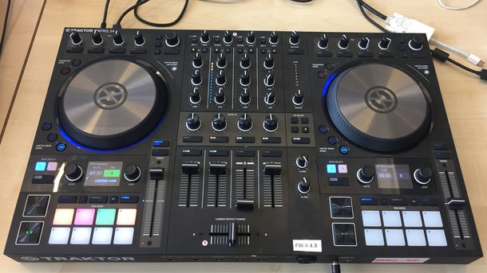](https://www.bonedo.de/fileadmin/_processed_/0/7/csm_05_Traktor-History2_844e836f3c.jpg)

*Nice thing: the Kontrol S4 MK3 tractor*

### Inner values

The software has also been revised, there are mixer effects (similar to the Pioneer Color-FX), a revised, darker user interface and an improved time stretching and pitch shifting algorithm, the élastiquePro V3, licensed by zplane.

So is that the promised retreaded tractor? No, because as we reported half a year ago, the [tractor will](https://www.bonedo.de/artikel/einzelansicht/native-instruments-kuendigt-neue-traktor-version-und-neue-hardware-an.html) drive [into the future on two](https://www.bonedo.de/artikel/einzelansicht/native-instruments-kuendigt-neue-traktor-version-und-neue-hardware-an.html) tracks. And Traktor Pro 3 is not yet the retreaded tractor version, but the successor to Traktor 2.11. But still the professional version, because the "new" tractor will still need some time ...

[](https://www.bonedo.de/fileadmin/_processed_/7/e/csm_06_Traktor-History2_08ed453446.jpg)

*Traktor Product Owner Friedemann Becker explains the new Traktor Pro 3 and gives an outlook on the future*

### Interview with Friedemann Becker (NI)

Friedemann Becker: “We are currently working on two different tractor versions in parallel. We started to set up the tractor from scratch about a year ago. But this is not the Traktor Pro 3, which is now coming on the market, but it is a parallel development. Something like that takes time and we will make this new software bigger step by step in close coordination with the users. That is why we will continue to maintain the current Traktor Pro for several years. "

### What's the deal with the new hardware?

Friedemann Becker: “We spent a lot of time supporting the new hardware properly. What is special about the new Kontrol S4 MK3 is the "Haptic Drive", a revolutionary new technology that did not exist in this way before. There are static jog wheels like the CDJs, there are these “turntable-like” controllers with a turntable motor and a disc with a spindle, while the haptic drive is a jog wheel with an intelligent motor that depends on where you touch it can show completely different behavior.

Nudged on the outside edge, the haptic drive builds up a very strong torque. If you put your hand in the middle of the jog wheel, the haptic drive is suddenly easy to stop, like a record on the slipmat. You can also make cue points noticeable with the motor. You can feel them while searching and scratching, like notches on the plate. With these innovations, we expect a completely new proximity to music, similar to a real record. The jog wheel actually turns like a turntable and due to the very high resolution of the haptic drive, you can also beatmatch it very well by hand.

[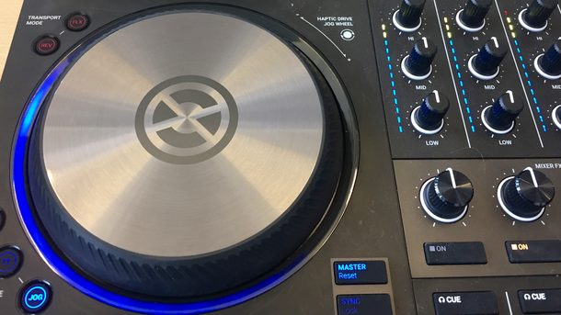](https://www.bonedo.de/fileadmin/_processed_/5/7/csm_07_Traktor-History2_8c23e708fe.jpg)

*The control of the Kontrol S4 MK3 is the real sensation of the Traktor Kontrol S4 MK3 and gives the jog wheel a resistance similar to that of a turntable motor*

When the new S4 MK3 was finally brought to life, it was another DVS moment for me. I had the feeling that we have once again taken a huge step forward in making the music tangible. The confidence-inspiring effect of the spinning wheels is astonishing from today's perspective - you have to have experienced it to understand what I mean.

The revolutionary thing is that the haptic wheel comes very close to the turntable, with a much more compact form factor. Some DJs have already said that it is the "better DVS" because it has fewer synchronization fluctuations than a turntable. The new Kontrol S4 MK3 represents a new generation of controllers, a compact but complete DJ setup with a mixer and the feel of two turntables. ”

### Is DVS now doomed to extinction?

Friedemann Becker: “Compared to today, the situation in the club used to be completely different: every club had a mixer and two turntables, and some might even have CD players. The two Traktor Scratch Vinyl in your pocket and your laptop replaced your entire record case. Nowadays it is almost a rarity if a club puts two turntables on the table. That's why I think that the time of DVS systems is slowly coming to an end. ”

[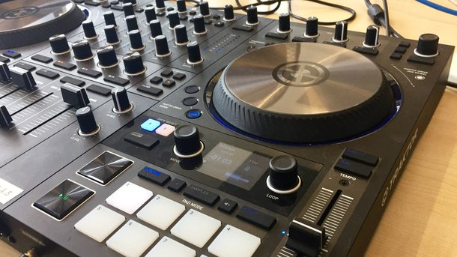](https://www.bonedo.de/fileadmin/_processed_/f/8/csm_08_Traktor-History2_c3ac12b67c.jpg)

*The new smaller display shows all relevant functions without much distraction*

### Is manual pitching a relic from the past?

Friedemann Becker: “I recently spoke to Chris Liebing about it and said that he is now pitching a lot more by hand. For example, if he goes on stage with Speedy J Collabs 3000, their setups are not linked, but they sync each other by hand. But even if he only plays on four decks, he only uses Sync to initially adjust the tempos of the tracks, but is still nudged afterwards because he can bring very different tensions into the mix with different offsets.

It is even better, he said, when the track always moves out slightly as before and you have to readjust it, because this creates a much greater dynamic in the set. In this respect, I think that manual pitching is not a relic, but is part of the nature of DJing.

### So is the main feature of Traktor Pro 3 really the support of the Kontrol S4 MK3?

Friedemann Becker: “You can put it that way. There are a few other features that are interesting for the pro user. By separating Traktor Pro and the new tractor, we place more value on professional users at Traktor Pro. We have completely revised the metering, we have made the master meter very long, we have installed a new, more transparent and very neutral limiter that comes from the machine. There is now also an indication of how strongly the limiter intervenes.

We are responding to the criticism of some users that Traktor is not loud enough compared to the CDJs and that is actually always due to the incorrect setting of Traktor, because Traktor as an all-in-one system has practically no large headroom with up to 16 stereo tracks had to compete against a pure stereo device. We have now put a lot of effort into it.

There's a new keylock algorithm that lets you pitch up to four semitones up and down without hearing anything disturbing. We’ve also introduced channel effects. In addition to the filter, there are now eight different effects in each channel. They are parameterized in such a way that it is neutral in the middle, a highpass-like build-up is triggered to the right, turned to the left it becomes duller and is good for mixing out. These channel effects are already configured so that you only have to turn a knob to create impressive effects. "

[](https://www.bonedo.de/fileadmin/_processed_/f/8/csm_08_Traktor-History2_c3ac12b67c.jpg)

*The Kontrol S4 MK3's haptic drive is the real sensation of the Kontrol S4 MK3 tractor*

*For years you have seen a dominance of Pioneer products in the DJ booth. The days when a lot of DJs played with laptops and tractors seem to be over, you can only see CDJ setups everywhere, which also has to do with the fact that DJs like this new standard only with their USB stick Gig to have to come and leave your own expensive equipment at home.*

### Are the clubs a market from which NI is now slowly saying goodbye or do you want to try - similar to Denon - to dock onto the Pioneer biotope or to establish your own biotope?

Friedemann Becker: “When we say: Traktor is back !, we mean it much broader than that there is only new software. The connection to the producing DJ gives us a unique selling point. In the future, Traktor will be seen more often in the DJ booth, in whatever way. Let yourself be surprised!

[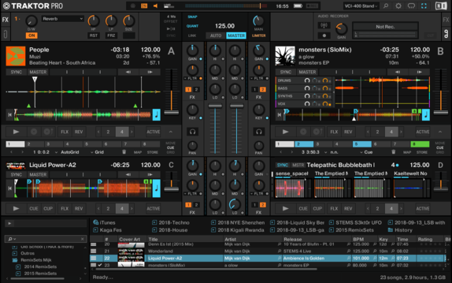](https://www.bonedo.de/)

*The tractor GUI got a facelift. More objective, darker, more club-friendly*

<https://de-bug.de/musiktechnik/entwickler-talk-traktor-scratch-pro/>

2.2.2009

## e Instruments has been heavily involved in the development of Traktor for years. We talked to him about the new Pro version.

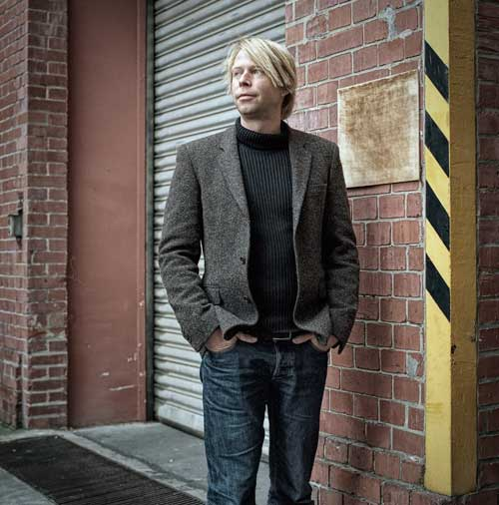Photo: [Andreas Chudowski](http://www.chudowski.de/)

by Thaddeus Herrmann from De: Bug [128](http://www.de-bug.de/mag/5986.html)

Everything new, everything better

**Debug:** You start with the slogan “DJs are so overrated” for the new tractor version. Is “Traktor Pro” really the definitive democratization of the music or just the enforcement of a new quasi-standard?

**Friedemann Becker:**Of course this is very humorous. Tractor is a tool, an instrument, and every tool has to be mastered. It is a learning process. Traktor is not an easy entry into DJing, it is the reaction to the increasing digitalization of DJing. It is a fact that it exists. We are more concerned with standards. That means: We want to pick up the users where they already felt comfortable without a tractor. Example: The Pioneer CDJs. You don't have to get used to Traktor Pro, you can just keep going. Because Traktor starts working with these CD players. The same goes for vinyl DJs. It's all about integrating old ways of working into a new system. Optimization of the workflow. Conversely, this does not mean that everyone who buys tractor is immediately a professional DJ.

**Debug:** The new version has the abbreviation “Pro” in its name. That is a clear reorientation.

**Friedemann Becker:** A lot has happened in the last year at Traktor. Since we have launched the vinyl version, there has been a whole new level of attention, tractor is taken much more seriously, especially by DJs who have been around for a long time and earn their money by DJing. The needs of these professionals were the focus of the development of the new version. This does not mean that amateur DJs cannot use the new version, on the contrary. But Traktor has grown up and is used by professionals, hence the "Pro" in the name and a radical optimization of the workflow.

**Debug:** What was important to you personally with the new version?

**Friedemann Becker:** convergence. Tractor has got more and more features over the years and versions, making it more and more confusing. This was particularly reflected in the workflow. I spent a lot of time figuring out how to best locate the functions, where which button makes the most sense, which features must be immediately and always directly accessible. The other focus was the controller. Operation of Traktor by MIDI controller is still on the advance and these users were the focus of the new version.

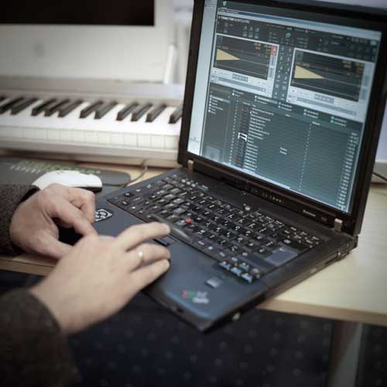Photo: [Andreas Chudowski](http://www.chudowski.de/)

**Debug:** Then let's stick to MIDI. There are radical changes that, among other things, mean that the controller assignments are no longer compatible with the new version ...

**Friedemann Becker:**At Traktor 3 we had the term “controller zoo” internally, by that I mean the internally assignable controllers, for example the volume of a deck. These controllers had grown more and more over time and were therefore no longer comprehensible in every situation. This has now been sorted out, we have cleaned up and clustered. Very important: We have also standardized. Imagine five MIDI controllers with a jog wheel. You can be sure that all jog wheels have a different range, different resolutions. We have now aligned everything internally and at the same time integrated even more controllers. We now supply presets for the 20 most popular controllers, so we're on the safe side for now. Unfortunately, this also means that the controllers, which we did not immediately consider a preset, must now be mapped again by the user. In the beta test, however, we quickly noticed that the users agree. The new possibilities outweigh the work of the new mapping.

**Debug:** Traktor is a kind of quasi-standard on the software side, but on the hardware side it looks very different, as you just described. In the club and on the stage, this leads to irritation because the old saying: Aha, there comes a DJ who needs two technics, is simply no longer valid.

**Friedemann Becker:** That's right. But we are far from saying: it has to work this way and that. We don't want to set a standard. With which hardware you work, whether you just hang up or mix DJ and your own live set ... you cannot predict that. These limits are dissolving more and more anyway. We simply want to offer enough interfaces so that everyone with a tractor can be as creative as they want. It's about supporting creativity and individuality and not about the Native Instruments standard.

**Debug:** Let's look at the new user interface ...

**Friedemann Becker:**The deck is still in the foreground. So no new adjustment is necessary. The detail section in tractor 3 was a big construction site, we have changed a lot. In the old version, this was the pool for all additional functions for all decks. This had consequences, for example we had to work with certain colors for certain decks in order to make the assignments clear. Not ideal in the club. Now all deck functions are back in the respective deck, in a collapsible and expandable menu below the waveform. Loops, cues, beat jumps are now where they belong. In addition, we now treat loops and cues equally. To say: A loop in the Traktor Pro is nothing more than a cue point with a certain length and also responds to the same hotkey. We have reserved the third submenu for beat matching and the grid. Here you can create a grid, edit it and also define it as the default so that I don't get lost. We have organized all of these functions thematically and given them a corresponding priority even after their advent in the DJ culture. Some things just have to be set once and then don't want to deal with them anymore. Above the decks there are only global functions, the master panel, effects etc. Some things just have to be set once and then don't want to deal with them anymore. Above the decks there are only global functions, the master panel, effects etc. Some things just have to be set once and then don't want to deal with them anymore. Above the decks there are only global functions, the master panel, effects etc.

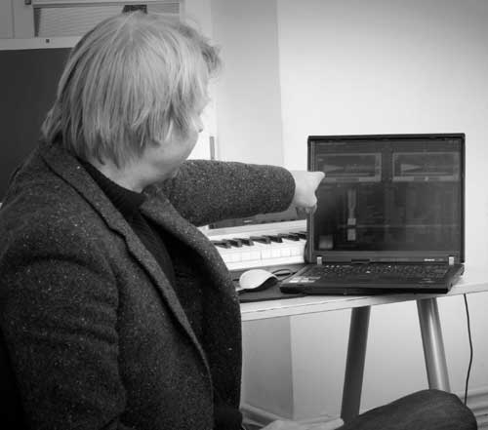Photo: [Andreas Chudowski](http://www.chudowski.de/)

**Debug:** A lot has **happened** with the effects.

**Friedemann Becker:** Yes. First of all, the routing is different. Effects are now set globally and then routed to the decks, and numerous new ones have been added. Each deck can access both effect racks at the same time. The effects view has also been redesigned. This is also related to the MIDI controllers, you only ever have a certain number of pots available to change the effects. There are various options here.

**Debug:** Delicate topic: The sound of effects. We all remember the Pioneer DJM-500 because the effects had such a characteristic sound. Which modalities do you use to decide which effects should be on board, and how do you ensure that you don't hear from a safe distance: Aha, that's tractor ...

**Friedemann Becker:** There are certain standards that have to be covered. Indeed, we looked at Pioneer devices to be guided by a widely used standard. However, some effects with Traktor Pro go further: Rhythmic is not only based on the BPM number, but also on the transients, so is even more precise. They follow the beat grid and that's tight. Our users highly appreciate tractor effects and are therefore a top priority for us. I don't want a characteristic tractor effect sound, so we are increasingly working on effects that deal with beat slicing etc. This means that clearly identifiable sounds can not occur so quickly.

**Debug:** The mixer is still enthroned in the middle ...

**Friedemann Becker:** ... which was also adapted. If you work with an external mixer, it will be hidden in Traktor Pro, you will only have functions that are a kind of add-ons. For example: a filter for each deck. Gain of course and also the headphones because you can listen to the beat grid.

**Debug:** The browser is essential for a system like Traktor ... I see cover art in the new version!

**Friedemann Becker:** Exactly, cover art is an innovation. We are cooperating with Beatport and the plan is for Beatport to deliver all the tracks with the artwork in a timely manner. And complete with all tags and even with the tractor beat grid. We worked on the artwork for a while. How do you do that in the list view of the browser? Without loading times and actually for the entire view in the browser ... that was tricky.

**Debug:** I was surprised, because you can only see the upper part of the artwork if you operate in a longer list ...

**Friedemann Becker:** But actually it corresponds exactly to the record box. You quickly skip through and just see the top edge of the panels. I think that's a good adaptation. DJs work the same way. Another important innovation in file management: All changes in files are written directly to the file. This greatly facilitates data exchange. With tractor 3 these settings were saved in the program. This new way also facilitates the exchange with iTunes, a standard that we had to face.

**Debug:** How important is it to support quasi-standards like iTunes?

**Friedemann Becker:** Extremely important. Many people manage their digital music with iTunes, are used to features that they can expect in other programs. Just as every spreadsheet program will always have an Excel import and export, we have to pay attention to accepted interfaces.

**Debug:** what else is new?

**Friedemann Becker:** For example, things that you deliberately don't think about. Legibility of the font in the interface, color relationships between the font and the background, the possibility of making the font larger ... the lighting conditions in clubs and on stages are rarely ideal, so we tried to react.

**Debug:** Computers are getting smaller, more portable. Programs are becoming increasingly complex. How do you deal with the contradiction that you have to communicate a lot on a small display?

**Friedemann Becker:** The redesign of the interface was, among other things, a reaction to exactly this trend. In addition: the resolutions of the displays are getting smaller. If you don't have any tools to implement a gentle resizing, you suddenly have an interface with completely wrong proportions. It's a challenge, of course. The trend towards ever smaller displays also contradicts what we know from our users: they don't want to call up any submenus or change levels during the gig.

**Debug:** Finally, let's get technical: Beatgrid and Beatjump have also been redesigned.

**Friedemann Becker:**Yes, for example, the quantize mode is new, which is very much in the direction of remixing and sequencing. Any jumps can be performed quantized. Unlike Ableton, Traktor Pro jumps immediately, but not to the starting point of the loop, but always to the corresponding point in the new section, it is inserted as an exact offset, we remain in the grid. Especially in connection with our four decks you can prepare real loop tracks and use them accordingly. This is a real sample player. The sync mode has also been revised. There is a kind of semi-intelligent master clock that is always based on the deck that is running straight. As soon as you jump, she looks for the next best reference. So you always have a tight synchronization. This is an optional feature you can also hide it if you want. Hard jumps in speed are “smooted” if you use Traktor as a master in a setup with several programs. Big innovation: automatic beat grid, new tracks are analyzed automatically. It was a big request from our users, it works very well with 4/4. Other rhythm structures can be touched up quickly by hand ...

**Debug:** DJs are so overrated. Why are such features so important? What you had to learn so painfully in classic DJing, but which is ultimately fun, is now completely automated.

**Friedemann Becker:** The craftsmanship shifts to other functions, but remains unchanged. You have a lot more options, you can play more sources at the same time, you can do tricks with more fun. And it is not that we impose these features on the user. It will always be the case that two tracks are arithmetically perfectly on top of each other, but they just don't groov. This is a central concept for us. All of these features are for reference only and can be ignored or tuned as soon as you notice that it just isn't grooving. Conversely, we hope that these features will save the DJs a lot of work and time, which they can then invest in more refined and more detailed sets.

**Debug:** We talked a lot about Traktor Pro and little about Traktor Scratch Pro. How important do you think timecode vinyl and timecode CDs are and how long will they be around?

**Friedemann Becker:** I am relatively certain that this will be done in a few years, because what users still experience with vinyl today will soon be experienced with controllers. This “hands on” is very, very relevant and at the moment simply cannot be implemented with MIDI, because the timecode wins. “Touching” the music will always be important.

[Native Instruments](http://www.nativeinstruments.de/)

<https://djtechtools.com/2011/02/11/the-history-of-traktor/>

The Evolution Of Traktor

[CONTROLLERISM](https://djtechtools.com/category/dj-gear/controllerism/)

[[https://secure.gravatar.com/avatar/65ddad441a6643550ea1c183eeeee31e?s=39&d=retro&r=g](https://djtechtools.com/author/emilbrikha/)By **Emil Beatsnatcher Brikha**](https://djtechtools.com/author/emilbrikha/) On **Feb 11, 2011**

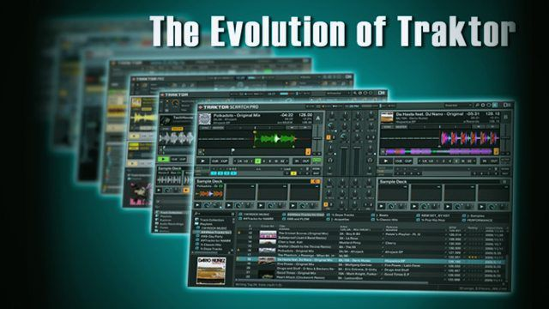

[99 Comments](https://djtechtools.com/2011/02/11/the-history-of-traktor/#disqus_thread)

**3**

Traktor was first introduced over 10 years ago, and since then, it has become an institution when it comes to digital DJing. The impact the software has had on the DJ scene as well as shaping the trends and developments is both undeniable and impressive. Looking back at the development of Traktor sparks nostalgia and warm fuzzy feelings very much like old school Nintendo does for many of us. In today’s article I will take you through the evolution of Traktor from 2000 through today.

The video below is a great example of how far digital DJing has come but continue reading for a look back to its humble beginnings.



I remember it like it was yesterday. I was in a pretty committed relationship with PCDJ when I first met Traktor and the chemistry was spot on. The switch was an obvious choice for me and I haven’t looked back since. Today, the market has branched off into many different focuses and styles of digital DJing with very impressive software like Ableton and Serato. Here is a look at how the program and the UI has changed over the years.

Traktor DJ Studio 1  
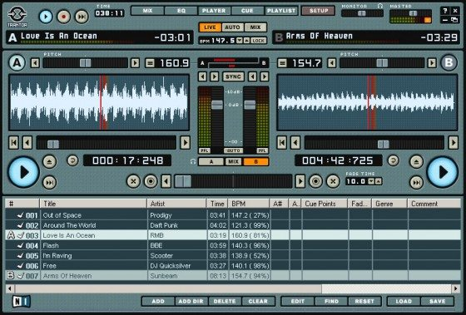

Traktor was first released in 2000. The initial versions were Traktor Studio and Traktor DJ, with Traktor Studio being more full-featured.

Traktor DJ Studio 2[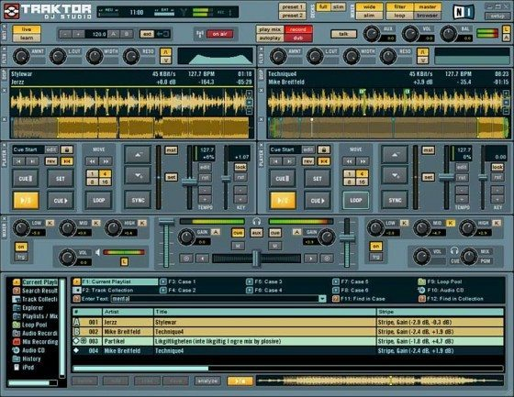](https://s11234.pcdn.co/wp-content/uploads/2011/02/Traktor-2.jpg)

In 2002, Traktor DJ Studio 2 was released, which offered several new features including scratch macros. It also expanded its looping, MIDI, and cue point functionality. In 2003, Traktor DJ Studio 2.5 was released. This new version expanded the time stretching functionality, added [Open Sound Control](http://en.wikipedia.org/wiki/Open_Sound_Control)(OSC) support, and gave the user limited ability to customize the look of the interface.

**Traktor Final Scratch**

[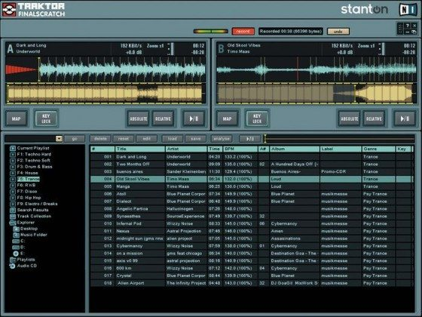](https://s11234.pcdn.co/wp-content/uploads/2011/02/finalscratch.jpg)

In 2003, Native Instruments partnered with Stanton Magnetics to develop the software for their “Final Scratch” digital vinyl system. This partnership gave Stanton a Win/Mac version of the Final Scratch software and allowed Native Instruments to use the Final Scratch timecode engine in their own Traktor line.

**Traktor 3**

[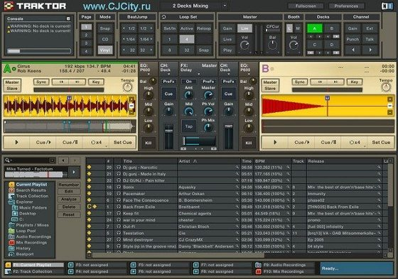](https://s11234.pcdn.co/wp-content/uploads/2011/02/traktor3.jpg)

In 2005, Native Instruments added vinyl emulation capability to version 2.6 of Traktor DJ Studio. Version 2.6 included live input, streaming internet broadcasting, support for more file formats, and greatly expanded MIDI capability. Soon afterward, Traktor DJ Studio 3 added two more playback decks (for a total of four), built-in effects, Beatport online store integration, a four-channel mixer, a Universal Binary version, deck caching, and minor improvements to existing features.

On October 11, 2006, the partnership between Native Instruments and Stanton Magnetics ended, and Traktor DJ Studio 3 was renamed Traktor 3.

Traktor Pro

[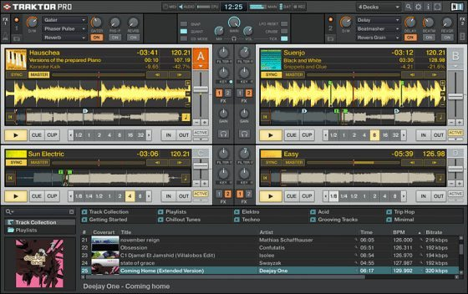](https://s11234.pcdn.co/wp-content/uploads/2011/02/Traktor-Pro.jpg)

In 2008, an updated version of Traktor Pro, and a new version of the DJ studio, Traktor Scratch Pro were released. Traktor Scratch Pro had additional DVS functionality enabled, including the specifically designed Audio 8 DJ audio interface, and timecoded CD or vinyl control.

Traktor Pro S4

[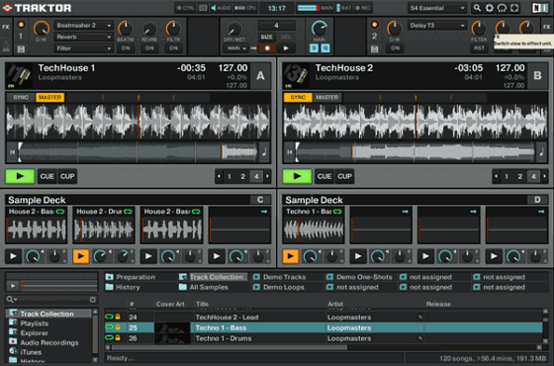](https://s11234.pcdn.co/wp-content/uploads/2011/02/Traktor-S4.jpg)

When Native Instruments released its newest DJ controller, the S4, it came bundled with an, in many ways redesigned software, adding sample decks among other things. The Traktor Pro S4 also became the natural inspiration for what came next.

Traktor Pro 2

[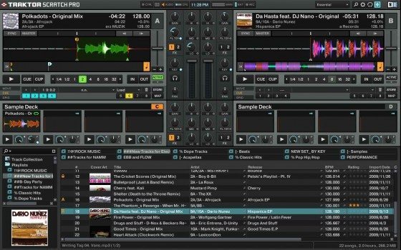](https://s11234.pcdn.co/wp-content/uploads/2011/02/Traktor_Pro_2_GUI.jpg)

On April 1st 2011, Native Instruments will release its newest DJ software and if you haven’t already[read our article](http://djtechtools.com/2011/02/10/traktor-pro-2-now-released/) with a solid 10 minute video walk through by Ean Golden, you should do that right now. In the meantime I’ll be right here, waiting for holographic DJing with Minority Report gestures.

Special thanks to [DJ FDRK](http://djfdrk.blogspot.com/), StuC and the people who posted in [the thread](http://djtechtools.com/forum/showthread.php?t=24720) which gave us the idea to put together this article.